 | Progression of Whole Class Texts  The English curriculum at Woodside Junior School stems from engaging class texts, whereby children become inspired to write from what they read and experience together. Children become familiar with drafting, writing, and editing several text types to suit different purposes (writing to inform, entertain, persuade, or discuss). Although we have published these texts as our intended stimuli for reading and writing, they are subject to change at teachers’ discretion as planning is adapted and altered to cater for the individual needs of a year group.
 | Year 3 | Year 4 | Year 5 | Year 6
Autumn | 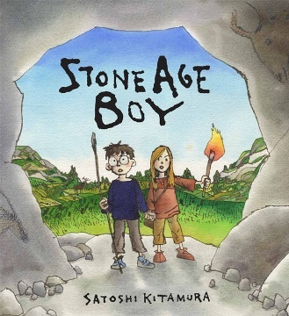  Stone Age Boy  by Satoshi Kitamura  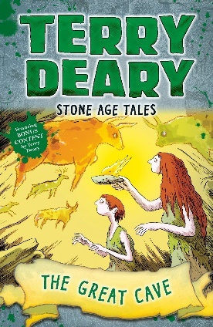  Stone Age Tales: The Great Cave  by Terry Deary  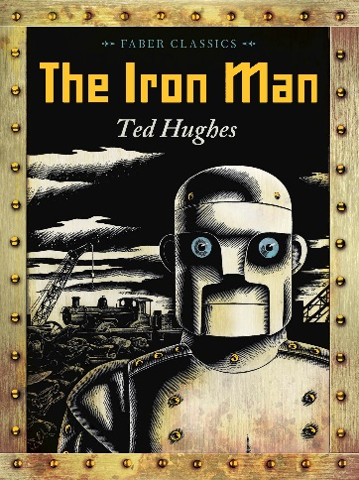  Iron Man  by Ted Hughes | 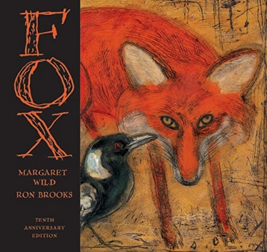  Fox  by Margaret Wild  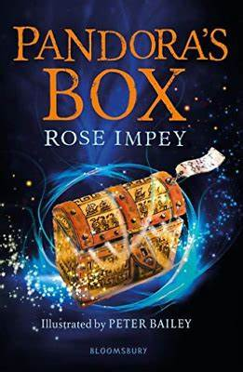Various Greek Myths (inc. Pandora’s box)  by Rose Impey  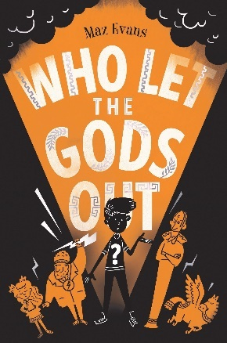  Who Let The Gods Out  by Maz Evans | 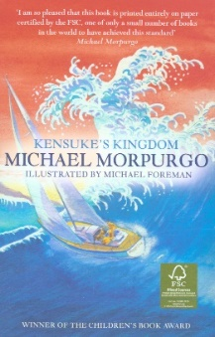  Kensuke’s Kingdom  by Michael Morpurgo  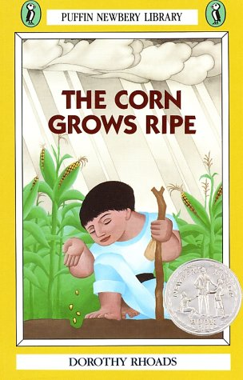  Corn Grows Ripe  by Dorothy Rhodes  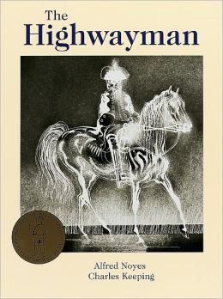  The Highwayman  by Alfred Noyes | 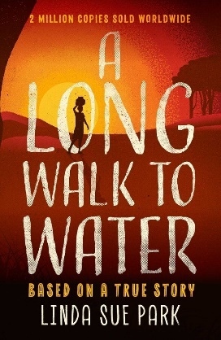  Long Walk to Water  by Linda Sue Park  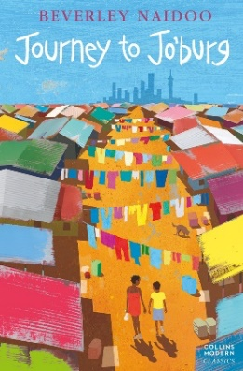  Journey to Jo’burg  by Berverley Naidoo  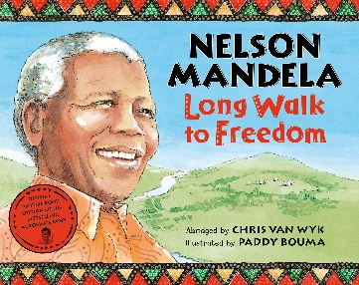  Nelson Mandela: A Long Walk To Freedom  by Chris Van Wyk  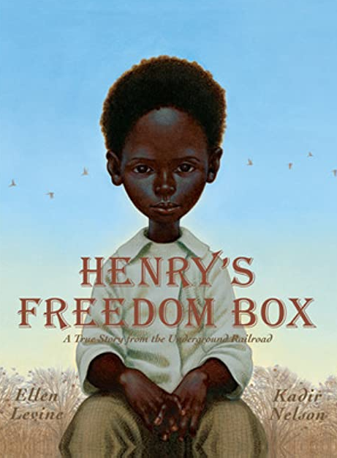  Henry’s Freedom Box  by Ellen Levine
Spring | 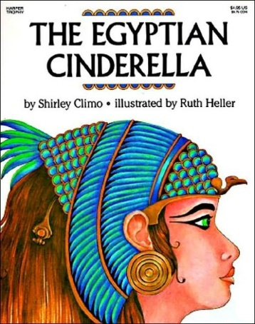Egyptian Cinderella  by Shirley Climo  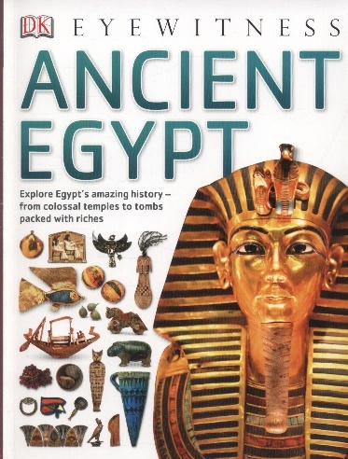  Various Non-Fiction texts about Ancient Egypt  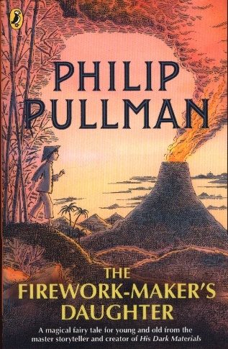  The Firework Maker’s Daughter  by Philip Pullman | 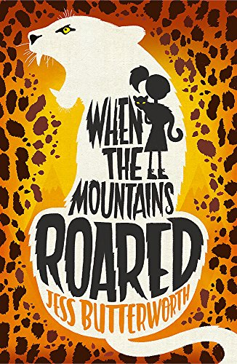When The Mountains roared  by Jess Butterworth    Survivors  by David Long  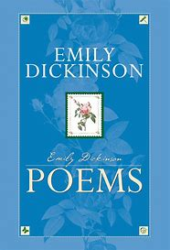  Various Mountains Poetry (including The Mountain by Emily Dickinson) | 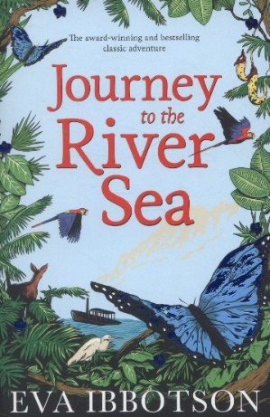  Journey to the River Sea  by Eva Ibertson    Various non-fiction articles: The Amazon Rainforest    Various non-fiction articles: Peggy Whitson (Astronaut) | 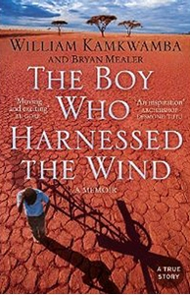  The Boy Who Harnessed the Wind  by William Kamkwamba  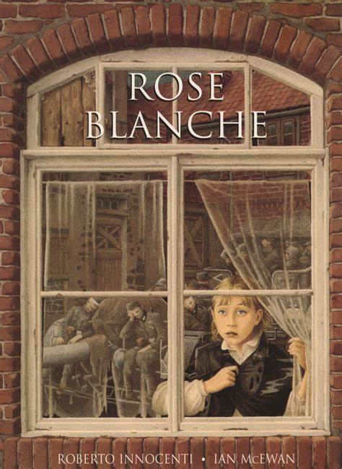  Rose Blanche  by Roberto Innocenti and Ian McEwan  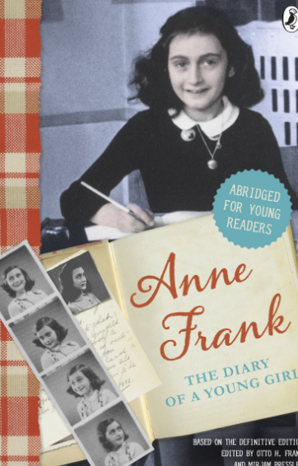  The Diary of Anne Frank (abridged for children)  by Anne Frank
Summer | 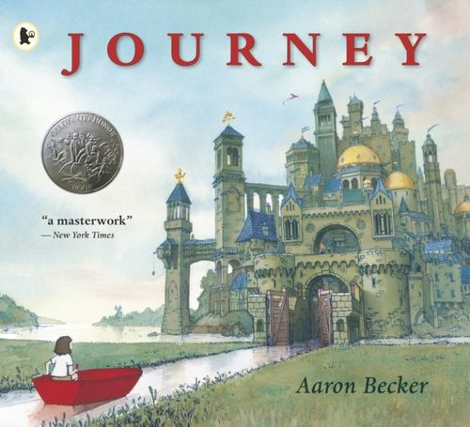  Journey  by Aaron Becker  Various Non-Fiction Tourist Leaflets | 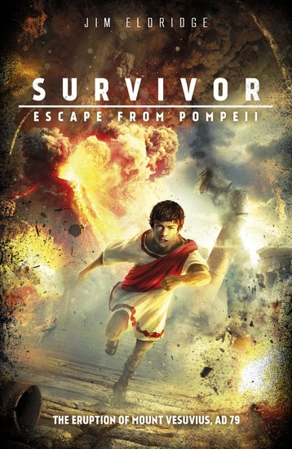  Survivor: Escape from Pompeii  by Jim Eldridge  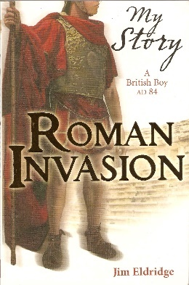  Roman Invasion (My Story)  by Jim Eldridge  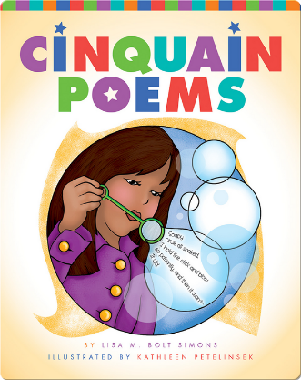  Various Cinquain poems | 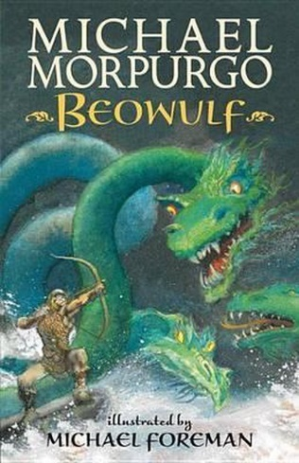  Beowulf  by Michael Morpurgo  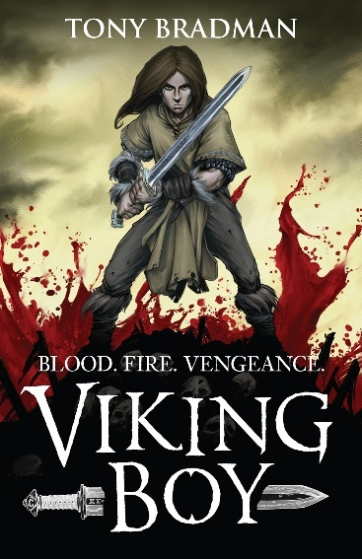  The Viking Boy  by Tony Bradman | 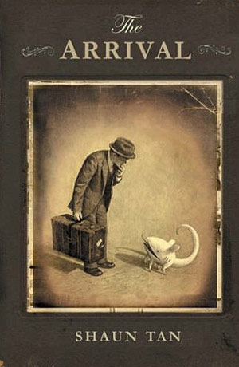  The Arrival  by Shaun Tan  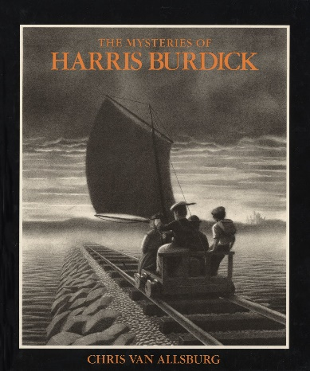  The Mysteries of Harris Burdick  by Chris Van Allsburg

